**Using the SupermarketCheckoutBasket application**

**Solution Layout**

Solutions consists of 3 projects

* SupermarketCheckoutBasketService
* SupermarketCheckoutBasketConsoleClient
* SupermarketCheckoutBasketTest

**SupermarketCheckoutBasketService**

Adding more Pricing Strategies

1. You can add more pricing strategies in the ‘PricingStrategyFactory’ class
2. Just amend the list in method ‘GetPricingStrategiesFromTempStore’

**SupermarketCheckoutBasketConsoleClient**

1. Ensure the project ‘SupermarketCheckoutBasketConsoleClient’ is setup as a Startup Project
2. Run the application

Note: to exit the application at any time, type ‘exit’

1. Console application will prompt following

**Please enter the SKU Code you wish to add to the basket**

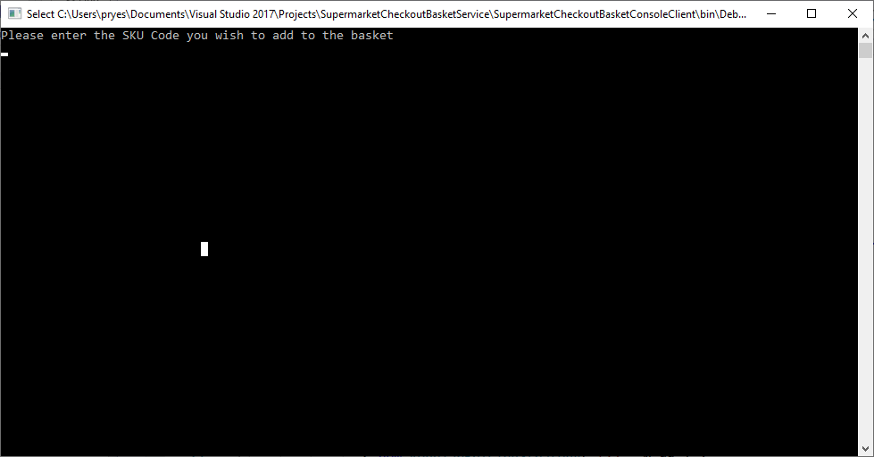

1. Type in the SKU Code

Note: if the SKU Code is less than 1 character or more than 4 characters – the system will prompt the user to re-enter the SKU code.

1. Press Enter
2. Console application will prompt following

**Please enter the amount of items**

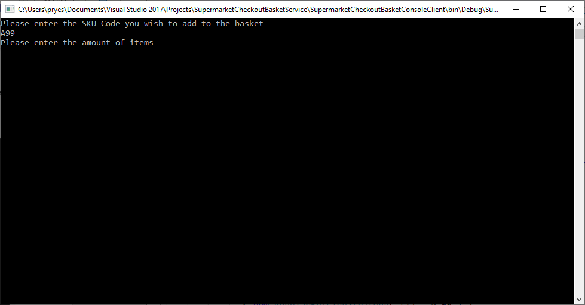

1. Type in a valid amount

Note: If an invalid amount is typed then the user is forced to re-enter their SKU code and amount

1. Press Enter
2. Console application will prompt following

**Do you wish to add more items to the basket, type ‘Y’ or ‘N’**

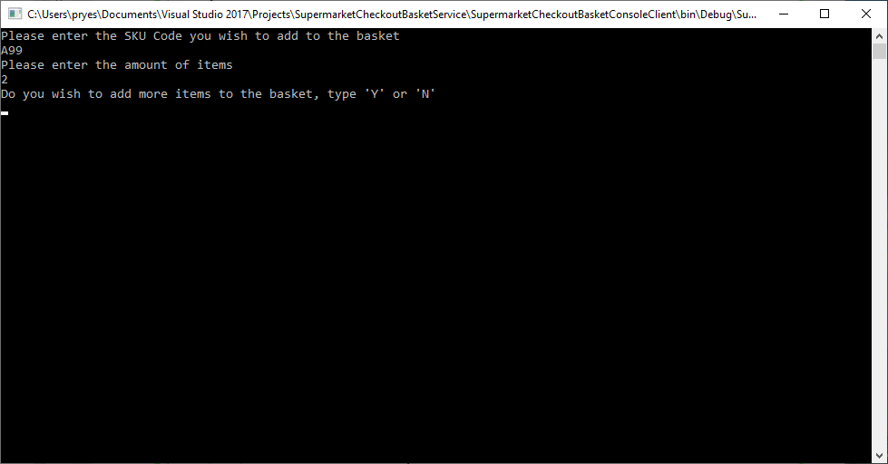

1. Typing ‘Y’ will go back to step 3
2. Typing ‘N’ will go and then display the final price

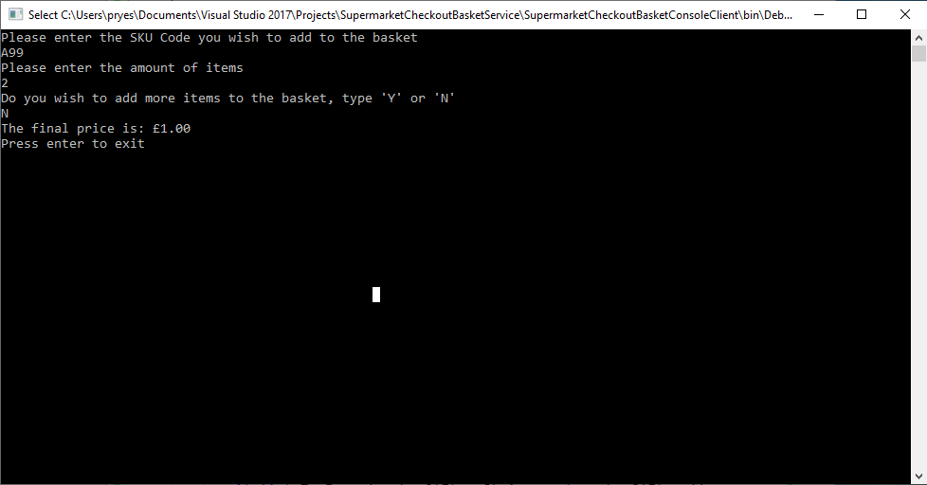

1. Press enter to exit

**SupermarketCheckoutBasketTest**

Tests for the cashier class has been implemented using NUnit